CHAPTER THREE: PROJECT IMPLEMENTATION/ACTUALIZATION
3.1 Introduction
This chapter represents the actualization of the Stock-Level Prediction Decision Support System (Dss), detailing the practical implementation of every stage of the project pipeline described in Chapter Three design. The system was built to forecast short-term demand for perishable grocery products so that reorder alerts and expiry-risk warning could be generated automatically, reducing both stockout and wastage for small retail stores. The workflow follows five actualizatied phases: data collection, data cleaning, data preprocessing, modelcreation and training, model testing and validation, and dashboard deployment. Each stage below documented the tools, code, and outputs produced, and is supported with screenshots of the actual deliverable generated at the stage, in line with the workflow first outlined in the project design from Section 3.2 onwards.

3.2 Data Collection
The raw data set souced as retail inventory CSV file (retail_store_inventory.csv) containing point-of scale (POS) transaction and stocl-level for five stores (S001-S005) and mutiple product categories, spanning the period 1 January 2022 to 1 January 2024. The dataset was loaded into Pandas DataFrame using Python, giving 73100 rows across 15 columns, including Date, Store ID, Product ID, Category, Inventory Level, Units Sold, Units Ordered, Demand Forecast, Price, Discount, Weather Condition, Holiday/Promotion, Competitor Pricing, and Seasonality. Because the project specifically targets perishable-goods stock prediction, the dataset was filtered to the ‘Groceries’ category only,reducing the working dataset to 14611 rows across 20 unique products and 5 stores. This filtered dataset formed the basis for all subsequent cleaning, preprocessing and modelling steps. I have also do the same with Rscript.

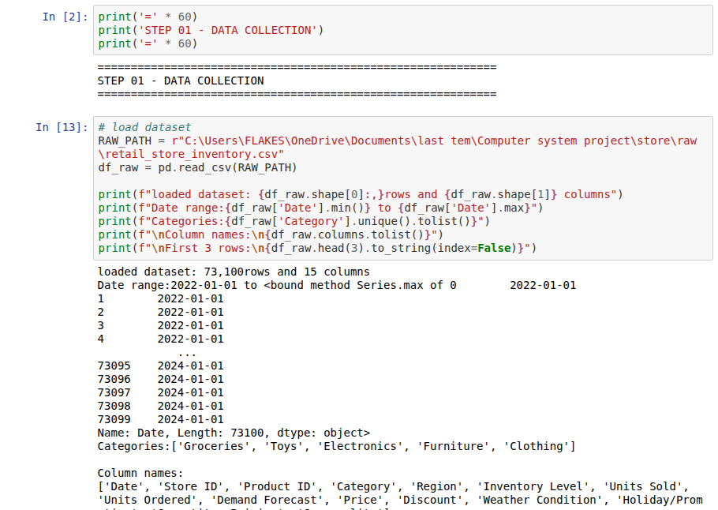

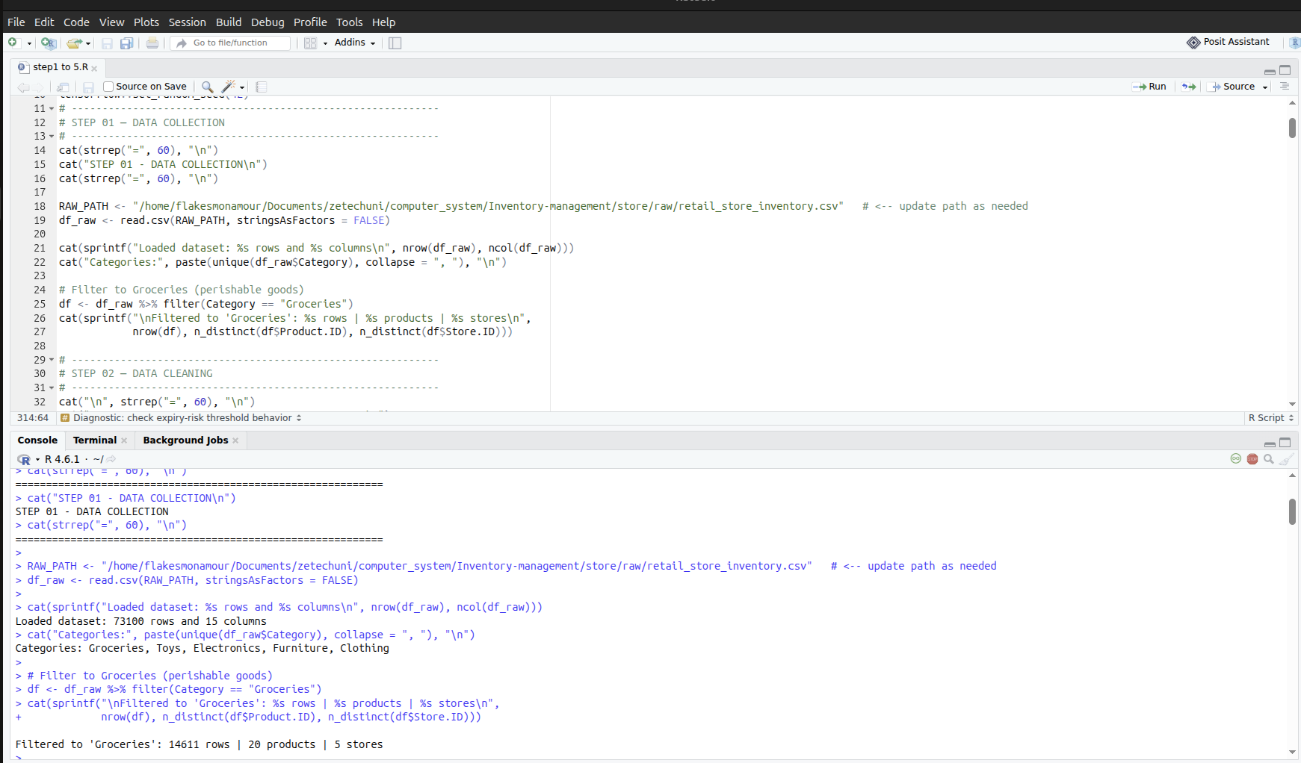

Figure 3.2: Data collection output showing the raw dataset shape, date range, category list and the filtered Groceries subset.

3.3 Data Cleaning
Following collection, the Groceries subset was cleaned to ensure consistency before feature engineering. Records were parsed into proper datetime objects and sorted by Store ID, Product ID and Date to preserve the temporal ordering required for time-series modelling. A completeness check confirmed no missing (null) values were present in the filtered dataset; nonetheless, a foward-fill/back-fill routine was applied per Store-Product group on the core numeric fields (Inventory Level, Units Sold, Units Ordered, Demand Forecast) as a safeguard against any future data gaps. Outlier detection wa then performed on the same numeric fiellds using the interquartile range (IOR) method, with values outside 1.5x IOR capped rather than removed, so that no rows were lost while extreme values could no longer disort model training.
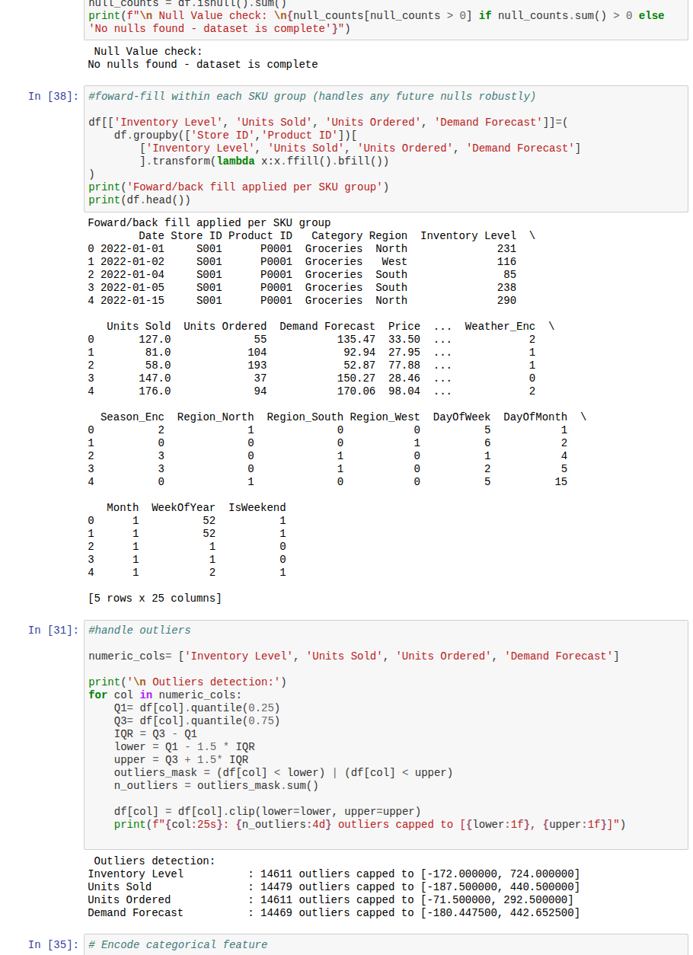

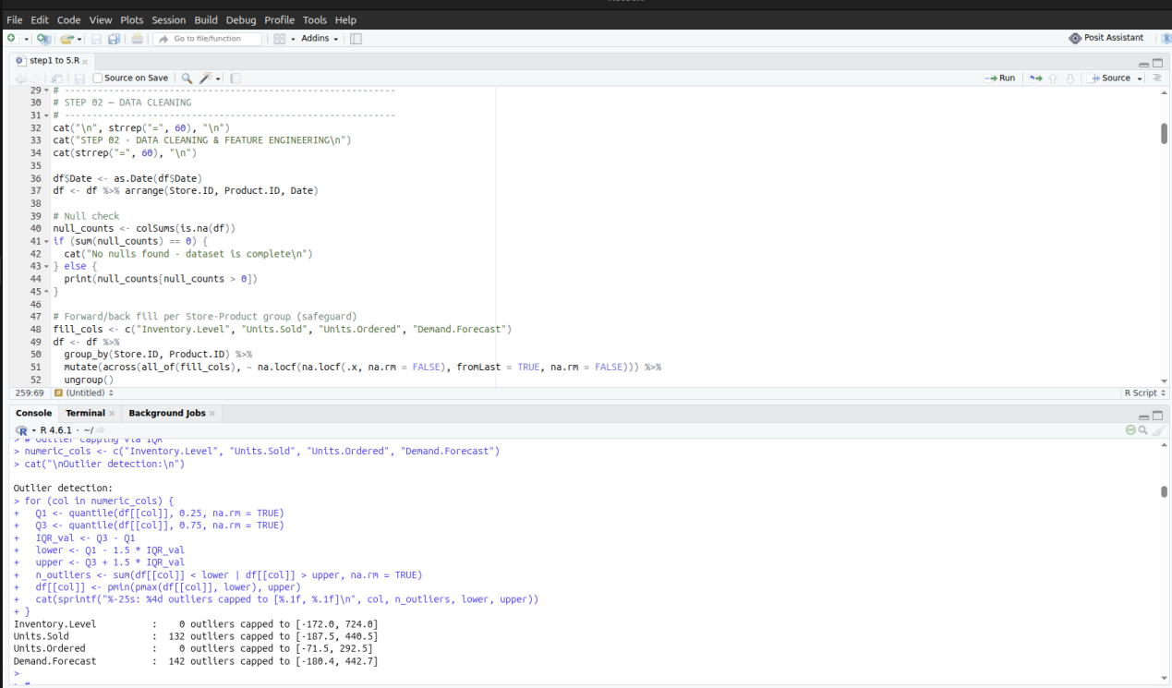

Figure 3.3: Data cleaning output showing the null-value check, foward/back-fill routine and IOR-based outlir capping.

3.4 Data Preprocessing
Preprocessing transformed the cleaned dataset into a model-ready feature set. Categorical fields were encoded numerically. Weather condition and Seasonality were label-encoded, while Region was one-hot encoded. Calendar-based features (day of week, day of month, month, week of year and a weekend flag) were derived from the Date column to capture seasonality patterns relevant to grocery demand. To give the models a sense of recent history, lag features for Units Sold and Inventory Level were generated at 1, 3, 7 and 14-day intervals, alongside 7-day and 14-day rolling mean and standard-deviation statistics. Rows containing nulls introduced by the lag windows were dropped, leaving 13,211 clean, feature-complete rows. All numeric features were then scaled to a 0-1 range using MinMaxScaler, and the dataset was split chronologically (no shuffling) into an 80% training set (10,568 rows) and a 20% test set (2,643 rows), preserving the time-series order required for forecasting.

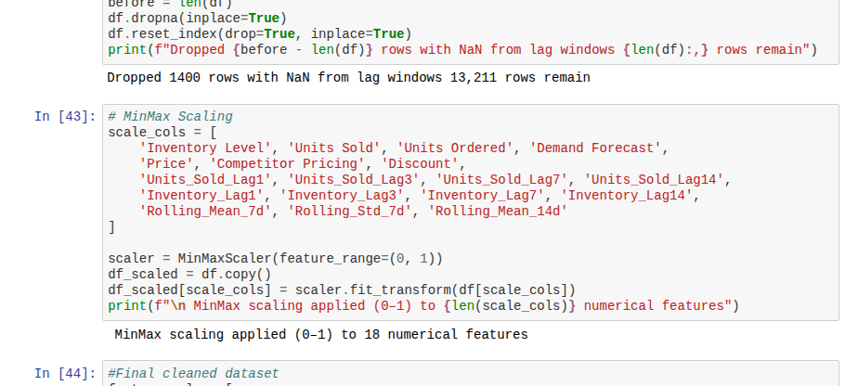
Fig 3.4: Preprocesiing output showing NaN-row removal after lag-window creation and MinMax scaling applied across 18 numerical features.

3.5 Exploratory Data Analysis
Exploratory data analysis was carried out on the the cleaned dataset and validation outputs to understand relationship between actual sales, model predictions, and inventory levels, and to sanity-check the DSS logic before deployment. A pair-plot comparing Actual, LSTM-Predicted, SVR-Predicted and Inventory Level values shows a strong linear relationship between the SVR predictions and actual units sold, while LSTM predictions cluster tightly around a narrow band, indicating limited variance in that model’s output. A store-versus-product demand heatmap was also generated to examin average demand distribution across the SKU catalogue, which additionally surfaced a data-coverage gap for store S004 relative to S005.
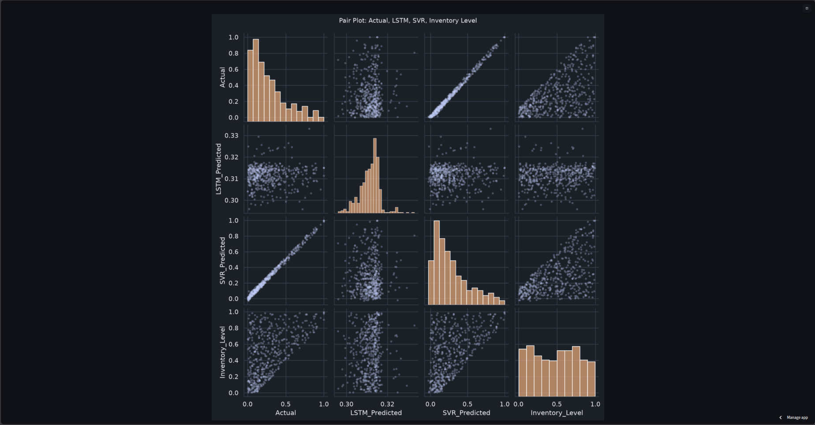
Figure 3.5.1: Pair-plot comparing Actual, LSTM-Predicted, SVR-Predicted and Inventory Level values from the validation dataset.

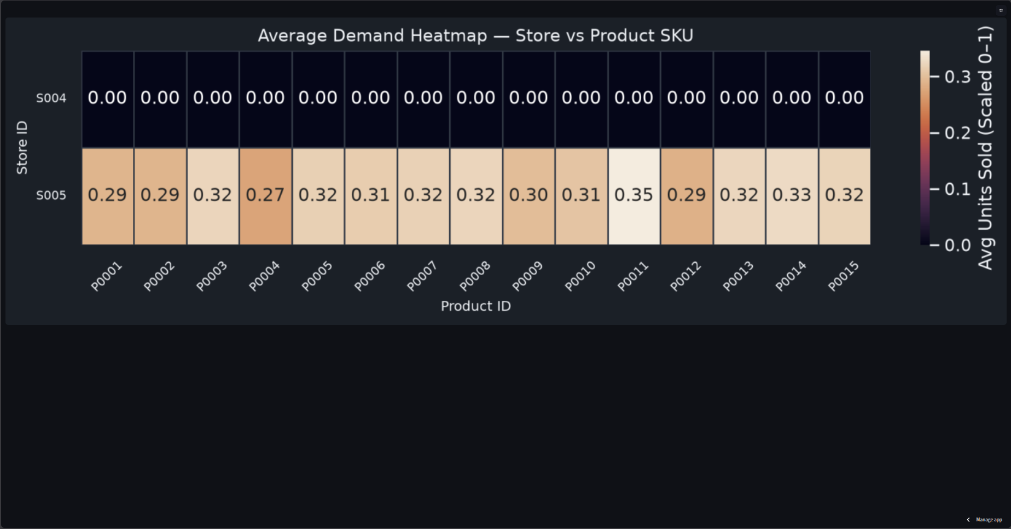

Figure 3.5.2: Average demand heatmap showing scaled units sold per store and product SKU.

3.6 Model Creation
Two forecasting models were created to predict scaled Units Sold: a Long Short-Term Memory (LSTM) neura; network built with TensorFlow/Keras to capture temporal sequence patterns, and a Support Vector Regression (SVR) model built with Scikit-learn to capture nonlinear feature relationships. For the LSTM, input sequences were constructed using a 14-day sliding window across the 28 engineered features, producing training and test tensors of shape (samples, 14, 28). The network architecture consist of two stacked LSTM layer (64 and 32 units) each followed by a Dropout layer (rate 0.2) for regularisation, a 16-unit ReLU Dense layer, and a single-unit output layer, totalling 36,769 trainable parameters. The model was complied with the Adam optimiser and mean squared-error loss. The SVR model was configured with an RBF kernel, C=100, epsilon=0.01 and gamma= ‘scale’, trained directly on the flat(non-sequenced) 28-feature training set.

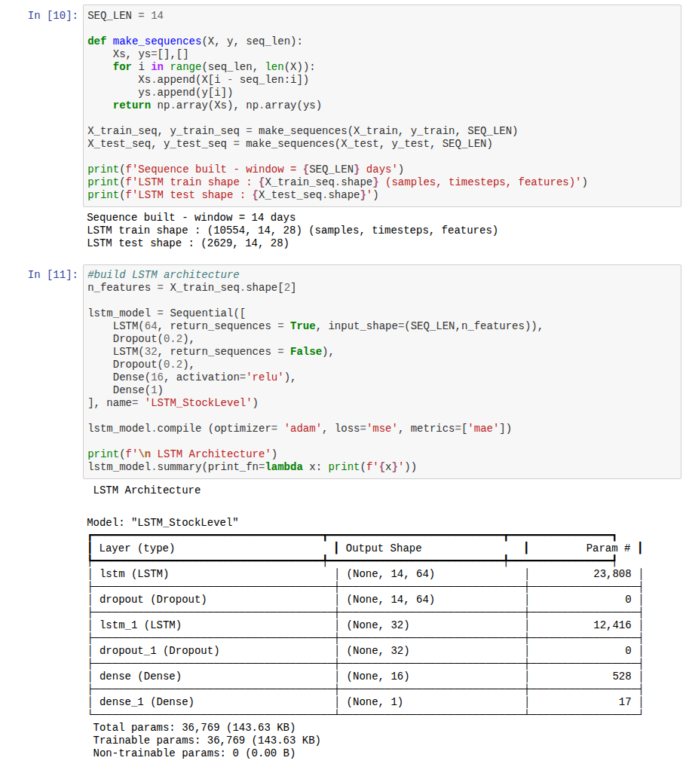
Figure 3.6: Model creation output showing the LSTM sequence shapes and the two-layer LSTM network architecture summary.

3.7: Model Training
The LSTM model was trained for up to 50 epochs with a batch size of 32 and a 15% validation split, using early stopping (patience of 5 epochs on validation loss) and a model checkpoint callback that persisted the best performing weights to lstm_best_model.keras. Training loss (MSE) and validation loss were tracked across epochs to monitor covergence and detect overfitting. The SVR model, by contrast, does not train iteratively over epochs; it was fitted in a single pass on the 10,568 row training set using it RBF kernel. Both trained artefacts, lstm_best_model.keras and svr_model.pkl, were saved and later loaded directly by the Streamlit dashboard for inference.

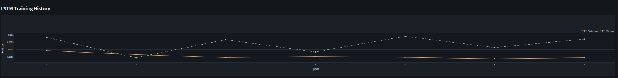
Figure 3.7: LSTM training and validation loss (MSE) across training epochs, as rendered on the deployed dashboard.

3.8 Model Testing and Validation
Both models were evaluated on the held-out 20% test set using symmetric Mean Absolute Percentage Error (sMAPE), Root Mean Squared Error (RMSE), and an accuracy score derived as 100 minus sMAPE. THe SVR model achieved an sMAPE of 17.70%, an RMSE of 0.0205 (scaled 0-1), and an accuracy of 82.30%. The LSTM model achieved an sMAPE of 72.35%, an RSME of 0.2475, and an accuracy of 27.65%, indicating that, on this dataset, the SVR model generalised substantially better to unseen data than the LSTM model. A5-fold, non-shuffled cross-validation was additionally run on the SVR model to confirm the stability of its RMSE across different time slices of the training data before the model was accepted for deployment.

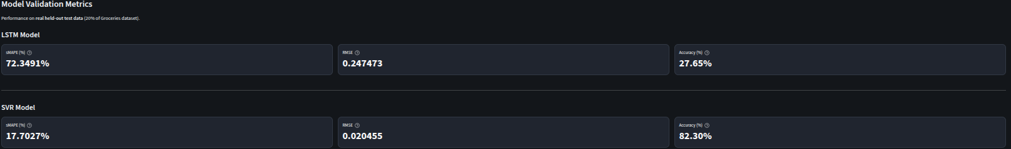
Figure 3.8 Model validation metrics for the LSTM and SVR models on the held-out test set, as displayed on the deployed dashboard.

3.9 Model Deployment
The trained models and validation outputs were deployed inside a Steamlit decision-support dashboard (step05_dss_dashboard.py), published to Sreamlit Community Cloud. The dashboard reads the saved model artefacts and generated validation files directly from the repository, requiring no live database connection for its default local-files mode. It exposes six tabs: Forecast Charts (actual versus LSTM/SVR predicted units sold and inventory level over time), Reorder Alerts (trigger when predicted demand exceeds 70% of current inventory), Expiry Risk( trigger when inventory exceeds 60% while predicted demands is below 30%), Model Metrics, Data visualization, and connections. The connections tab additionally documents and support an optional MySQL/MariaDB persistence path: a mini_market_dss database with inventory_records, forecast_outputs and model_metrics tables, populated either through the bundled Python/MySQL connector script or directly through a database client such as MYSQL workbench, allowing forecast outputs and model metrics to be written to a relational database for teams that need persisted queryable history beyond the local validation files.

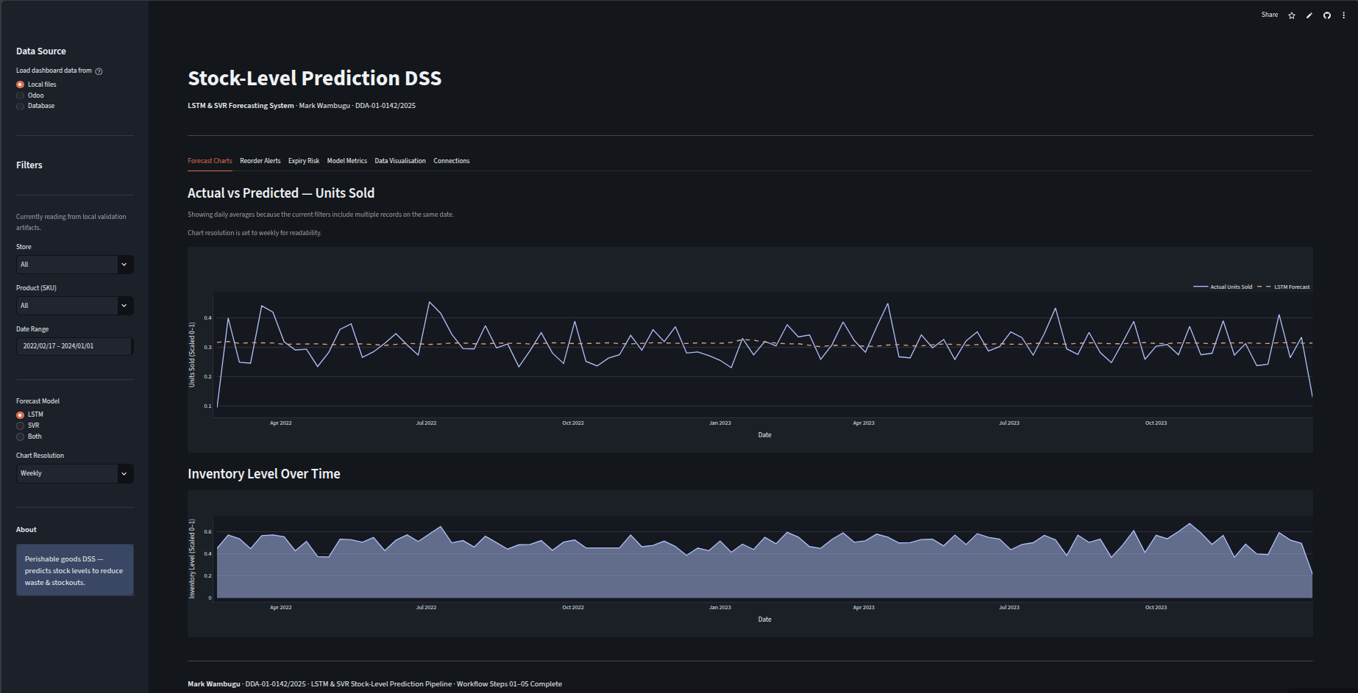
Figure 3.9.1: Deployed Stock-Level Prediction DSS dasboard on Streamlit Community Cloud, showing the Forecast Chart tab.

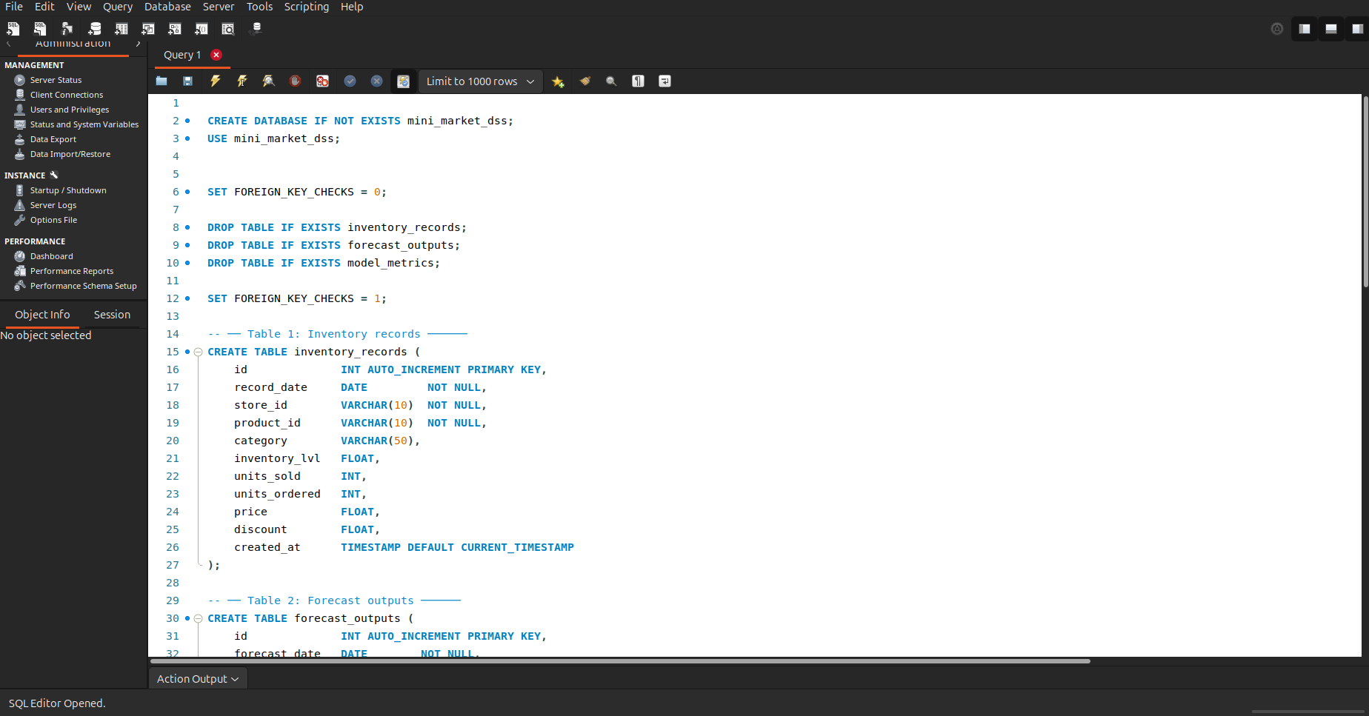

Figure 3.9.2: MySQL database schema fo the mini_market_dss database, created to support the dashboard’s optional database persistence path.

